CellPoint Remote Configurator - User Guide

Revision 1.0

Accessing the System
Website URL:
http://cellpoint.datasense.net:5025/
- Open your web browser (Chrome, Edge)
- Type or paste the URL above into the address bar
- Press Enter to load the login page
Logging In
- Enter your username and password
- Click the Login button
- You'll see the main dashboard with your assigned devices

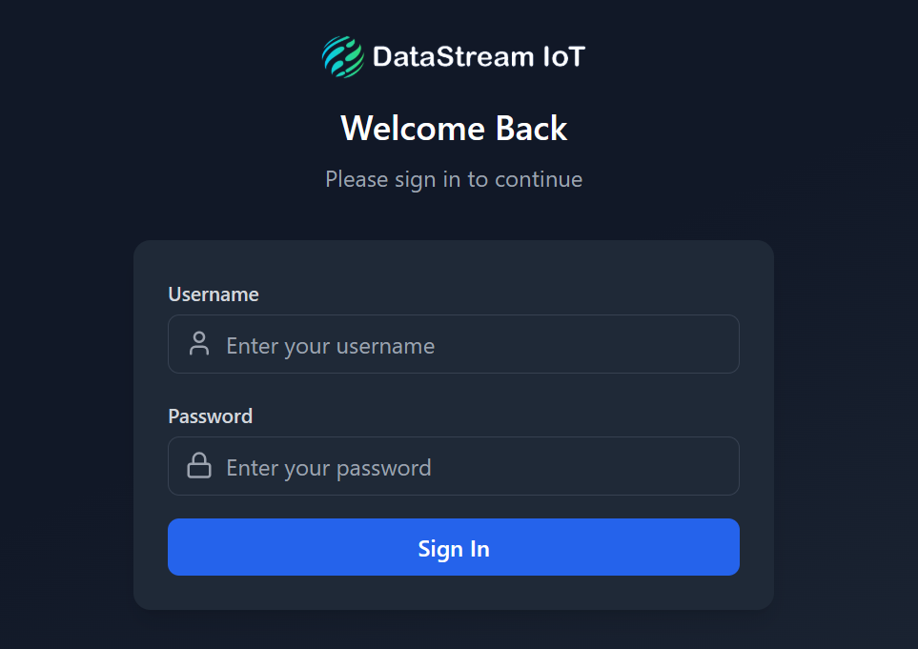

Main Dashboard
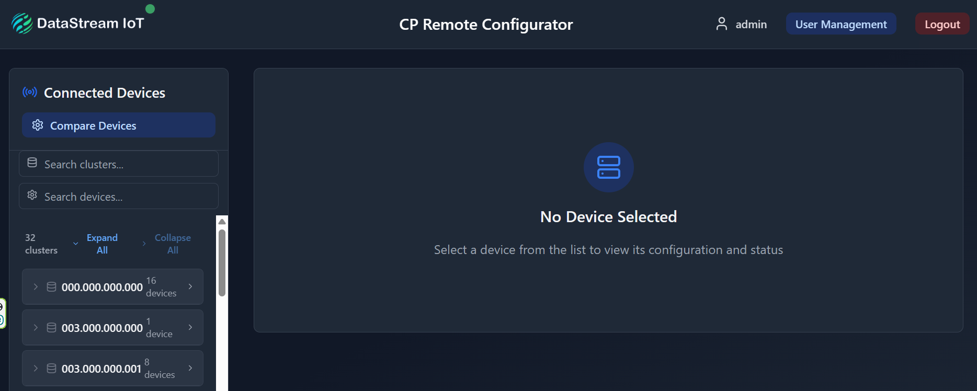
The screen is divided into two main sections:
Left Panel (Device List)
- Shows all devices you have access to
- Organized by clusters (groups of devices)
- Search bars at the top to find specific devices
Right Panel (Device Details)
- Shows configuration and settings for the selected device
- Different tabs for different types of information

Finding Your Devices
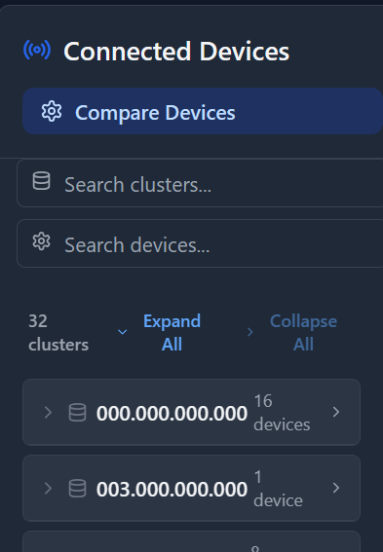

Search Options
Search by Cluster:
Type in the top search box to filter clusters
Example: Type "003.001" to find clusters starting with that
Search by Device:
Type in the second search box to find specific devices
Example: Type "033" to find all water meters

Viewing Device Configuration
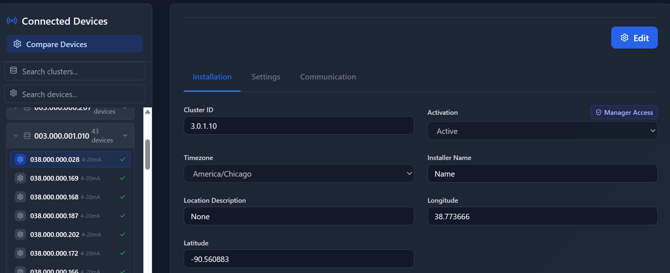
Selecting a Device
- Click on any device from the list
- The right panel will show the device details
- You'll see three tabs at the top:
  - Installation - Location and basic info
  - Settings - Device-specific configuration
  - Communication - Network settings

Editing Device Settings
How to Edit
- Select a device from the list
- Click the Edit button (blue button at the bottom)
- Modify the settings you need to change
- Click Save Changes when done
- Or click Cancel to discard changes

Important Notes: Fields marked with "Manager Access" require manager permissions Grayed-out fields cannot be edited by regular users

Configuration Tabs
Installation Tab
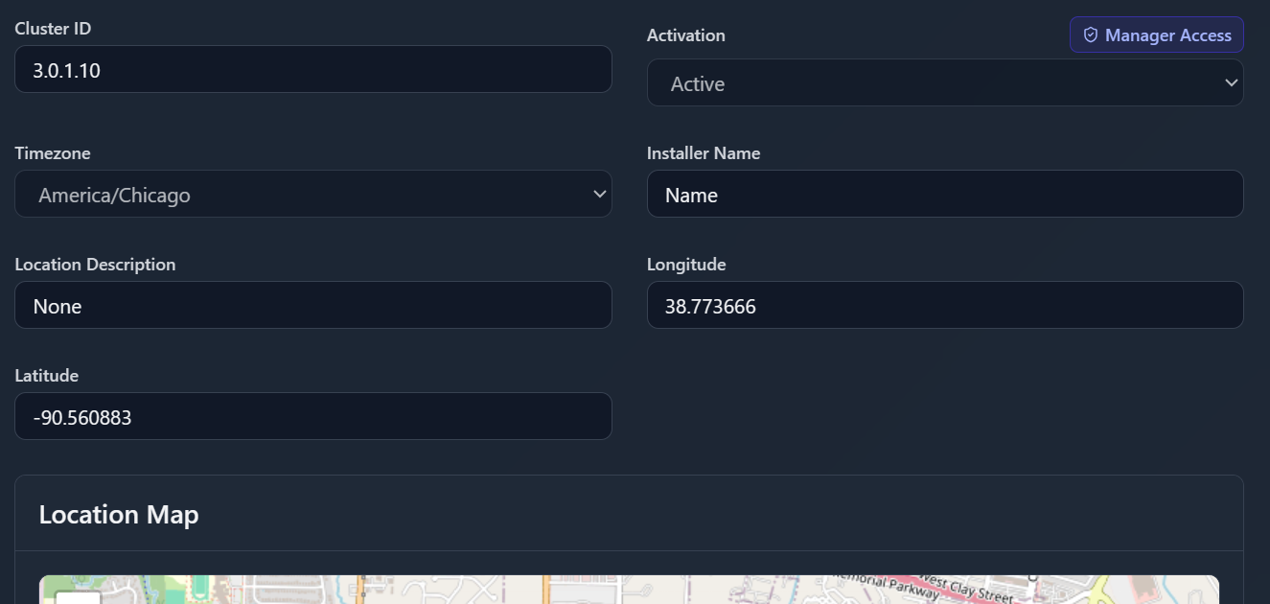
Location Information:
- Timezone - Set the device's time zone
- Installer Name - Record who installed the device
- Location Description - Describe where the device is located
- Latitude/Longitude - Set device coordinates
- Map View - See the device location on a map
Settings Tab
Device-Specific Configuration
The settings vary by device type:
Water Meter Settings
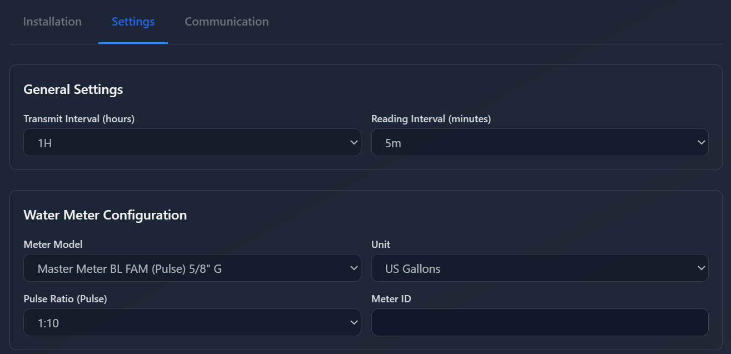

- Transmit Interval - How often the device sends data (hours)
- Reading Interval - How often the meter is read (minutes)
- Meter Model - Type of water meter installed
- Unit - Measurement unit (Liters, Gallons, Cubic feet)
- Pulse Ratio - Meter reading ratio
- Meter ID - Unique identifier for the meter
4-20mA Sensor Settings:

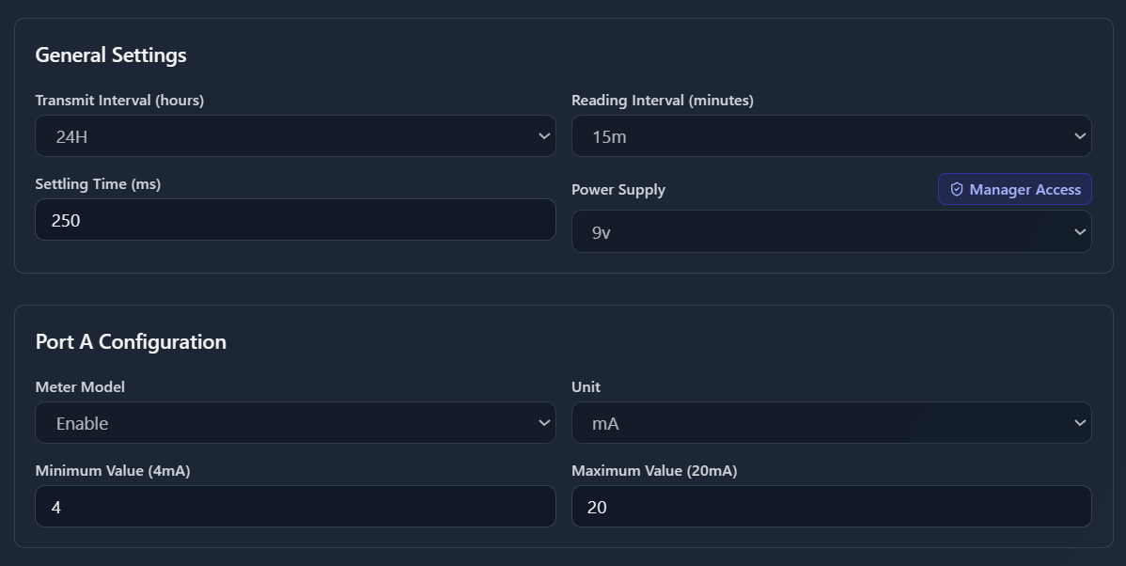

- Transmit Interval - How often data is sent
- Reading Interval - How often readings are taken
- Settling Time - Wait time before reading (milliseconds)
- Port A/B Configuration - Settings for each sensor port
- Meter Model - Enable or disable each port
- Unit - Type of measurement
- Min/Max Values - Calibration range

Alert Configuration (for 4-20mA sensors):
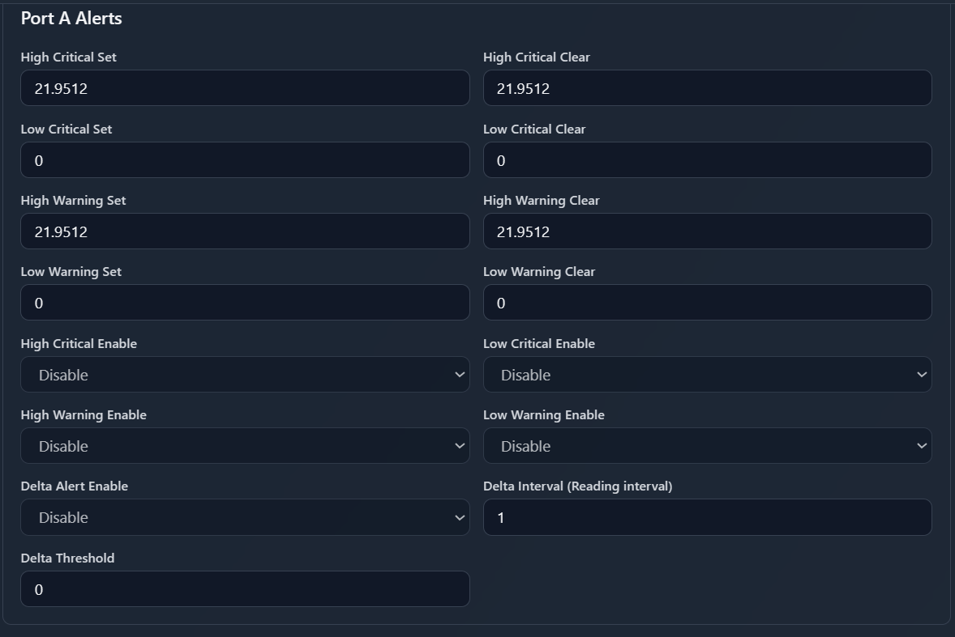
- High/Low Warning - Set warning thresholds
- High/Low Critical - Set critical alarm levels
- Enable/Disable - Turn alerts on or off
- Delta Alerts - Detect sudden changes
Loadcell Settings:
- Similar to 4-20mA but specific to load measurement
- Coefficients A & B - Calibration values
0-10V Sensor Settings:
- Similar to 4-20mA but for voltage sensors
- Two ports (A and B) can be configured independently

Communication Tab
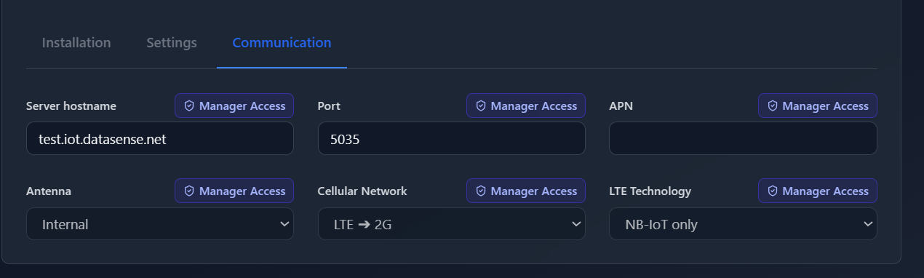
Network Settings (Usually locked for regular users)
- Server hostname - Where data is sent
- Port - Communication port number
- APN - Mobile network access point
- Antenna - Internal or external
- Cellular Network - LTE, 2G, or mixed
- LTE Technology - CatM or NB-IoT options

Device ID Prefixes
Devices are identified by their ID number:
- 033xxx = Water Meter
- 038xxx = 4-20mA Sensor
- 043xxx = Loadcell
- 044xxx = Tilt Sensor
- 046xxx = 0-10V Sensor

